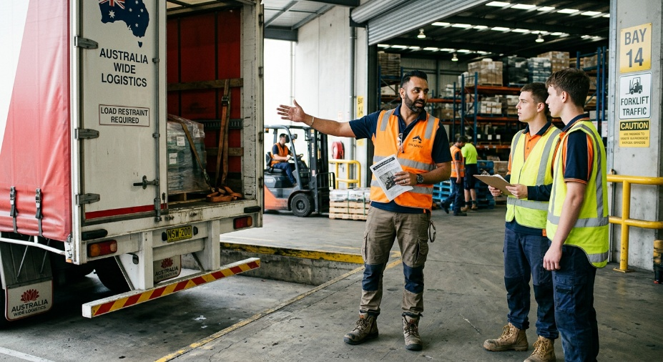
Learner #3: Arjun Patel

About Me: | Arjun is a 37-year-old Shift Lead at Linfox's Prospect depot in Adelaide's inner north, where he supervises a team of twelve drivers and loaders on the afternoon roster. He has worked across retail and transport for the better part of a decade and is the depot's go-to person for Chain of Responsibility compliance and load restraint queries. Arjun lives in Prospect with his wife and two teenage kids, and his shift pattern (typically 14:00 to 22:00) means most of his admin and study time falls into the late evening.
Professional and Learning Experience: | Arjun holds a current High-Risk Work Licence (LF), a current White Card, and a Statement of Attainment for two units (TLIF1001 and TLID1001) toward TLI32416 Certificate III in Logistics. His Senior First Aid lapsed in 2023 and is on his list to renew. He has eight-plus years of practical experience: five at BigMart Retail as a Floor Supervisor (2016 to 2020), and Shift Lead at Linfox since 2021. Arjun has also taken a six-month industrial heavy-lift contract at the Whyalla Steelworks Outbound Hub, where he developed dogging and slinging competence beyond standard warehouse work. He volunteers at Meals on Wheels on Wednesday mornings and recently coordinated a 150-sandwich Scout Group fundraiser.  Arjun has done plenty of informal training: rapid-fire onboarding of six Christmas casuals at BigMart in 2020, ongoing buddy-system inductions for new Linfox casuals, and pre-start safety briefings on the loading dock. He is enrolled in TAE40122 with the support of his employer.
Career/Training Goals: | Arjun's stated goal in his most recent performance review is to move out of the heavy lifting on the dock and into a full-time Compliance Trainer role within Linfox. The motivation is partly career progression and partly physical: he has been increasingly cautious about the strain of dock work and is keen to transition into a role that uses his head rather than his back. He is open to further qualifications beyond the Cert IV if they help him pivot into a permanent training and assessment position.
Working Style and Preferences: | Arjun is a natural one-on-one coach and is widely respected by the casuals and second-year drivers he buddies up with. His Operations Manager describes his training style as “very on-the-fly” with no formal lesson plans and no written assessments, and his most recent appraisal identified “Staff Development” (3 out of 5) as his weakest KRA precisely because his coaching is informal, unrecorded, and reliant on shadowing rather than structured instruction. Arjun has been candid that his paperwork is “not as good as my technical work” and that he is keen to learn how to map workplace tasks to formal training package requirements. His written communication tends to be brief and functional; he relies on the safety officer (Sarah) to take and write up the formal monthly compliance meeting minutes that he chairs.  Arjun manages a chronic lower-back issue that he picked up over years on the dock; he wears a back support belt for any sustained lifting, has been advised by his GP to limit prolonged sitting to 45 minutes at a time, and prefers to alternate between sitting and standing during desk-based work. He has his own laptop at home and is comfortable with email, the Linfox intranet, and basic Excel, but he avoids long blocks of typing and tends to dictate longer messages into his phone.
Additional Information: | Arjun is heavily involved in his local Scout Group and coaches his son's junior cricket on weekends. He has mentioned that he gets a bit fidgety in long sit-down sessions and will usually take a stretch break every 30 to 45 minutes, regardless of the setting. His preferred way of consuming new content is short videos or in-person walkthroughs rather than dense written manuals.

